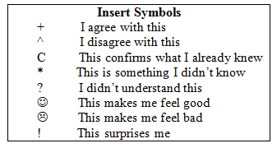
*You may also use your own symbols or write comments.

